ARION 16.07
Kleinschulen in Europa
Small Schools in Europe
School Developement, School Profiles, School Program

Study Visit in Salzburg
Headteachers, Inspectors, Counsellors, Educational Experts
Bulgaria, Czech Republic, Germany, France, Great Britain
Greece, Hungary, Lithuania, Poland, Slovakia

Studienbesuch in Salzburg
Direktoren, Berater, Schul- und Bildungsexperten
Bulgarien, Tschechien, Deutschland, Frankreich
Griechenland, Großbritannien, Ungarn, Litauen, Polen, Slowakei

ARION Study Visit
Small Schools in Europe – Kleinschulen in Europa
Participants
Headteachers, Counsellors and Educational Experts
Direktor/innen, Berater/innen und Bildungsexpert/innen

Working Languages
English, German - Englisch, Deutsch

Describtion & Objectives
Das Seminar informiert über die Herausforderungen, die an kleine Volks- oder Grundschulen bzw. Hauptschulen in ländlichen Gebieten gestellt werden. Die Entwicklung der Schulen sowie die Anpassung an die lokale Gemeinschaft in der Kommune werden behandelt. Der Wirkungsgrad der von kleinen Schulen als Bildungszentrum ausgeht, soll dargestellt werden.
Kleinschulen, Schulentwicklung und Multimedia, Schulprofil, Leitbildentwicklung und Schulprogramme an Salzburger Schulen, Trends der Schulentwicklung an Pflichtschulen in geographisch benachteiligten Schulen, Schulqualität an Pflichtschulen in Salzburg, Schulbesichtigungen, Netzwerke und Partnerschaften.

The seminar informs about challenges which confronts small schools in Europe in the near future. The developement, the strategies of quality management in schools in local communities and the effectiveness and the efficiency of small schools will be focussed from the point of all stakeholders (teachers, parents, pupils, headteachers, sponsors and politicians)
The following items will be presented: focus on school profile, mission and school programmes and quality management, school developement in compulsory schools in Salzburg, trends, facilities, objectives and measure, school visits, networking and cooperation.
Hosting of seminar participants by:
Prof.Mag. (FH) Marina GROGGER marina.grogger@pi.salzburg.at
Europa Service, Erzabt-Klotz-Str.11, 5020 Salzburg

In-Service Teacher Training Institute of Salzburg
Erzabt-Klotz-Str.11, 5020 Salzburg
Tel. 0043-664-4249416, Tel. 0043-662-840322-39, Fax. 0043-662-848728
Private Mobile Tel. (arrival on Sunday: 0043-664-6492974)

Draft Programme in Salzburg
Sunday, 13th march, arrival in Salzburg
Hotel Weiße Taube, Kaigasse 9. 5020 Salzburg, Tel. 0043-662-842404, Fax: 0043-662-841783
Price per person/day, single room, breakfast, EURO 54.50
Web: http://www.weissetaube.at/, Mail: hotel@weissetaube.at

Monday, 14th march, 09.00 – 18.00
Welcome reception by:
Ing. Mag. AL JOSEF PROMMEGGER; Headteacher, Pedagogical Institute Salzburg
Dr. AL WOLFGANG HÜBL, Head of Department, Higher Academic Schools- Ped. Institute
- Teacher Training Institute, Pedagogical Institute Salzburg
- School system in Austria, Theme of the week
- Programm of the seminar week
- ARION and SOCRATES – European Union funded programmes
- Presentation of the participants
Guided Tour to the City of Salzburg
Report of the Week - Structure
Tuesday, 15th march, 09.00-17.00
Welcome reception by
BSI Josef Irnberger, Chief Authority, Regional Educational Board Hallein
- School Visit: Hauptschule Kuchl, School Profile and Focus on Language, Sports,etc
- Discussion and Presentation of the participants
- School Visit: Volksschule Dürrnberg, Small School –located in the area of Hallein
Cultural Visit: Salzwelten Hallein

Wednesday, 16th march, 09.00 – 18.00
- School Visit: Wirtschaftskundliches Realgymnasium, School Developement - Secondary Academic School, Lower and Upper Form
- Wielandner Hauptschule Bischofshofen
Networks: COMENIUS Projects, Schools in rural area
- ARION, Interim Report, Hotel Brückenwirt
Cultural Visit: Stadtbesichtigung St. Johann/Pg, Bräuche und Traditionen

Arrival: Hotel Brückenwirt & Tennerhof, 5600 St. Johann/Pg, Tel. 0043-6412-4259, Fax: 06412-4259-55 www.hotel-brueckenwirt.at, info@hotel-brueckenwirt.at

Thursday, 17th march, 09.00 –18.00
Welcome reception by BSI Robert Griessner, Chief Authority, Regional Educational Board of Lungau
- School Visit: Sonderpädagogisches Zentrum Tamsweg, Integration and Inclusion
- School Visit: Kleine Volksschule mit Bildungszentrum (Musik...)
- Small Schools, Discussion and Conclusion, Networking Small Schools in Europe
- Tourism Center Obertauern, Economy and Tourism Industry

Friday, 18th march, 09.00 – 14.00
- School Visit: Volksschule Pfarrwerfen, Cooperation with parents and the community
- ARION Final Report
Departure to Salzburg
www.------Education, Quality in Schools....
www.bmbwk.gv.at
www.eu.int
www.de.gov.ni
www.seelb.org.uk
www.cea.org.uk
www.irlgov.ie
www.ippn.ie
www.ncca.ie
www.smm.lit
www.windlesham.surrey.sch.uk
www.nscl.org.uk
www.enis.is.no
www.sklenettet.is.no
www.statped.no/english
www.qis.at
www.benchmarking.co.at
www.land.salzburg.at/europa

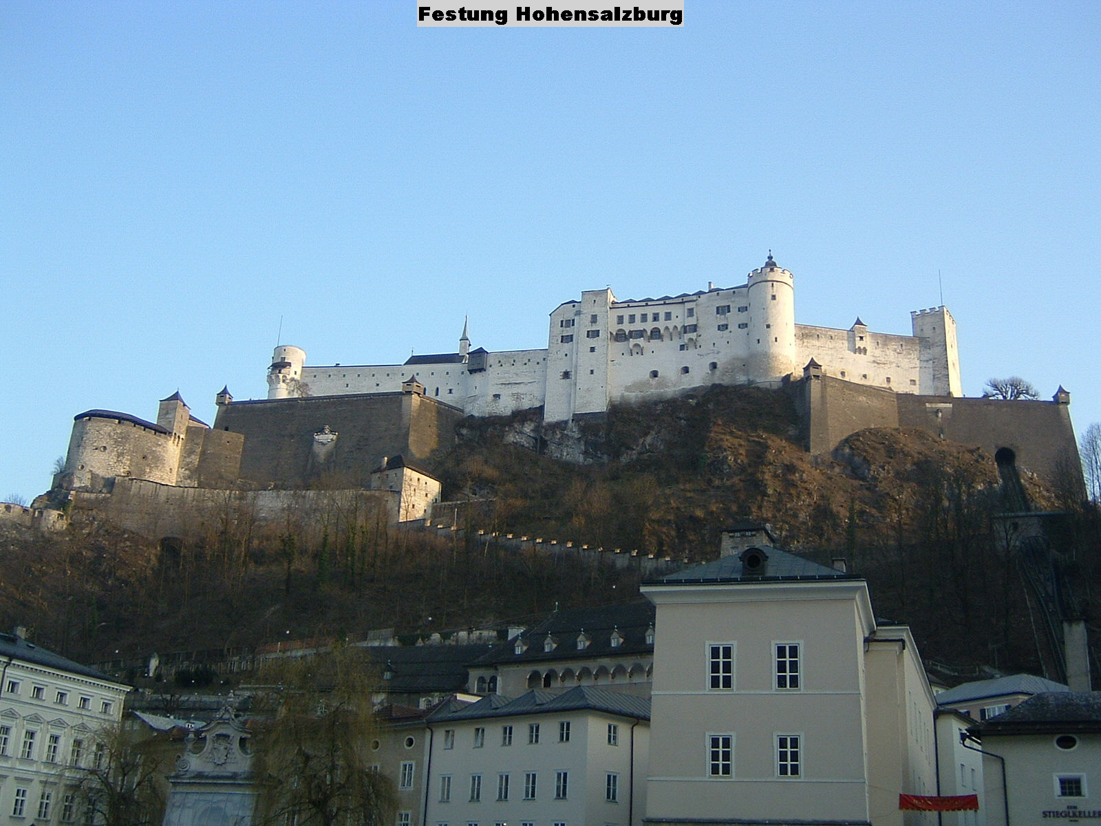
Salzburg, 23th February, 2005 Prof. Mag. (FH) Marina GROGGER

